Lab 10 Methods

LAB 10 Methods

Introduction (Concept Map)
In this lab we will get more familiar with what methods are and why we need to use them. The reader will be shown how to declare methods, what parameters are and what a method’s signature is, how to call a method, how to pass arguments of methods and how methods return values. At the end of this chapter we will know how to create our own method and how to use (invoke) it whenever necessary. Eventually, we will suggest some good practices in working with methods.

A method is a basic part of a program. It can solve a certain problem, eventually take parameters and return a result. A method represents all data conversion a program does, to resolve a particular task. Methods consist of the program’s logic. Moreover, they are the place where the “real job” is done. That is why methods can be taken as a base unit for the whole program. This on the other hand, gives us the opportunity, by using a simple block, to build bigger programs, which resolve more complex and sophisticated problems. Below is a simple example of a method that calculates rectangle’s area:
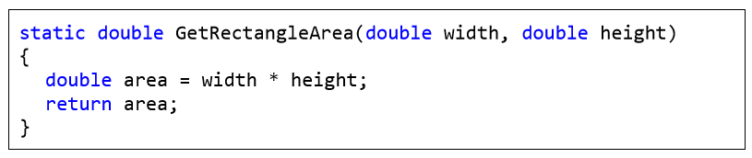
Method Declaration
To declare a method means to register the method in our program. This is shown with the following declaration:
As can be seen the type of returned value is void (i.e. that method does not return a result), the method’s name is Main, followed by round brackets, between which is a list with the method’s parameters. In the particular example it is actually only one parameter – the array string[] args. The sequence, in which the elements of a method are written, is strictly defined. Always, at the very first place, is the type of the value that method returns <return_type>, followed by the method’s name <method_name> and list of parameters at the end <param_list> placed between in round brackets – "(" and ")". Optionally the declarations can have access modifiers (as public and static).
The list with parameters is allowed to be void (empty). In that case the only thing we have to do is to type "()" after the method’s name. Although the method has not parameters the round brackets must follow its name in the declaration.
For now we will not focus at what <return_type> is. For now we will use void, which means the method will not return anything. Later, we will see how that can be changed The keyword static in the description of the declaration above is not mandatory but should be used in small simple programs. It has a special purpose that will be explained later in this chapter. Now the methods that we will use for example, will include the keyword static in their declaration.

Rules to Name a Method
It is recommended, when declare a method, to follow the rules for method naming suggested by Microsoft: - The name of a method must start with capital letter. - The PascalCase rule must be applied, i.e. each new word, that concatenates so to form the method name, must start with capital letter. - It is recommended that the method name must consist of verb, or verb and noun. Note that these rules are not mandatory, but recommendable. If we aim our C# code to follow the style of all good programmers over the globe, we must use Microsoft’s code convention. A more detailed recommendation about method naming will be given in the chapter "High-Quality Code", section "Naming Methods". Here some examples for well named methods:
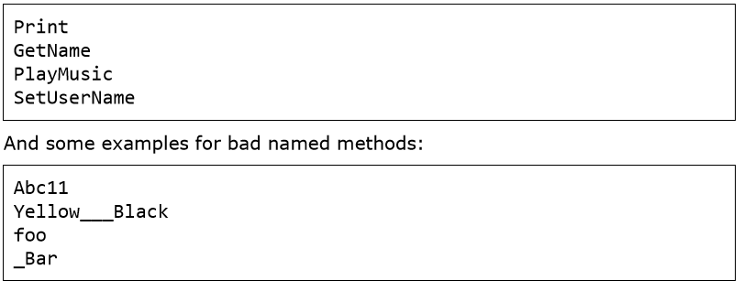
Method Overloading
When in a class a method is declared and its name coincides with the name of another method, but their signatures differ by their parameters list (count of the method’s parameters or the way they are arranged), we say that there are different variations / overloads of that method (method overloading). As an example, let’s assume that we have to write a program that draws letters and digits to the screen. We also can assume that our program has methods for drawing strings DrawString(string str), integers – DrawInt(int number), and floating point digits – DrawFloat(float number) and so on:
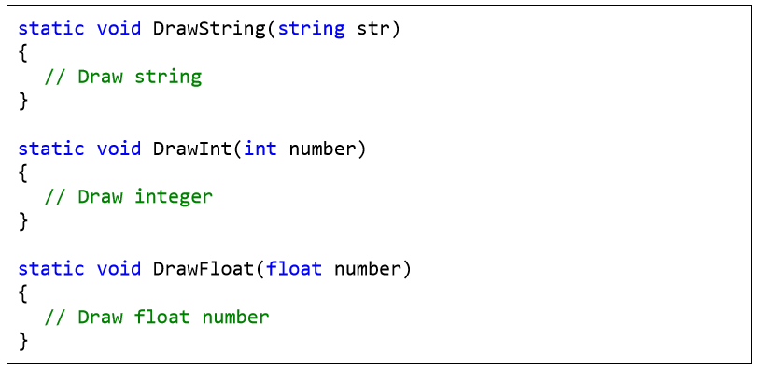

Practice Lab Tasks

- Write a method named square_cube() that computes the square and cube of the value passed to it and display the result. Ask the user to provide the integer input in the main() and then call the function.
- Write a method table() which generates multiplicative table of an integer. The function receives three integers as its arguments. The first argument determine the table to be generated while the second and the third integer tell the starting and ending point respectively. Ask the user to provide the three integer as input in the main().
- Create two function to find min and maximum value of any int array.
- Take input of an array in on method and print reverse of that array.
- Design a fully functional calculator using function.
- Design a WFP of your marks sheet.
For(int i=5;i<10;i++)
Result=2*i

