FOR LOOP

  - For Loops
For-loops are a slightly more complicated than while and do-while loops but on the other hand they can solve more complicated tasks with less code. Here is the scheme describing for-loops:
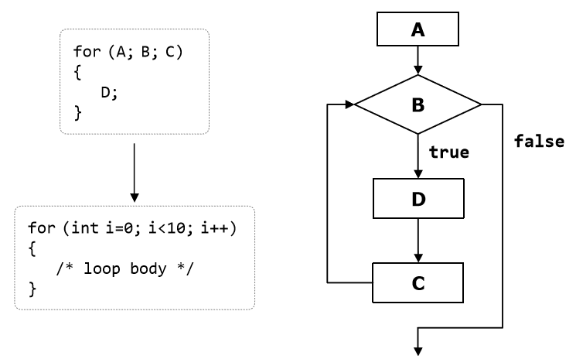
They contain an initialization block (A), condition (B), body (D) and updating commands for the loop variables (C). We will explain them in details shortly. Before that, let’s look at how the program code of a for-loop looks like:
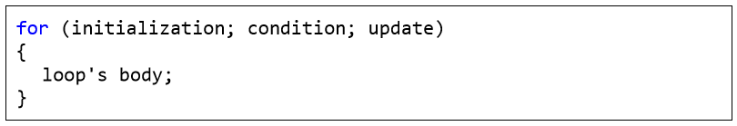
It consists of an initialization part for the counter (in the pattern int i = 0), a Boolean condition (i < 10), an expression for updating the counter (i++, it might be i-- or for instance, i = i + 3) and body of the loop.
The counter of the loop distinguishes it from other types of loops. Most often the counter changes from a given initial value to a final one in ascending order, for example from 1 to 100. The number of iterations of a given forloop is usually known before its execution starts. A for-loop can have one or several loop variables that move in ascending or descending order or with a step. It is possible one loop variable to increase and the other – to decrease. It is even possible to make a loop from 2 to 1024 in steps of multiplication by 2, since the update of the loop variables can contain not only addition, but any other arithmetic (as well as other) operations.
Since none of the listed elements of the for-loops is mandatory, we can skip them all and we will get an infinite loop:
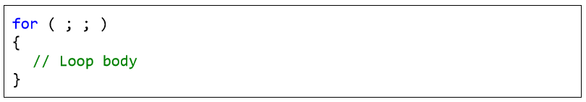
Now let’s consider in details the separate parts of a for-loop.

Initialization of For Loops
For-loops can have an initialization block:
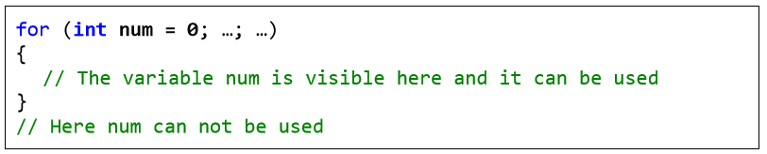
For-loops can have an initialization block:
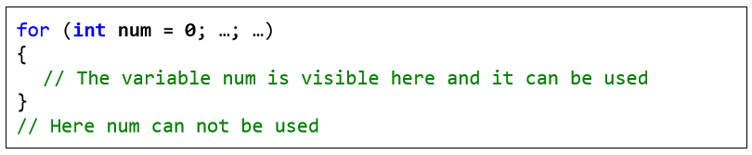
It is executed only once, just before entering the loop. Usually the initialization block is used to declare the counter-variable (also called a loop variable) and to set its initial value. This variable is "visible" and can be used only within the loop. In the initialization block is possible to declare and initialize more than one variable.

For-loops can have a loop condition:
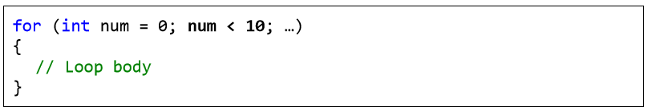
The condition (loop condition) is evaluated once before each iteration of the loop, just like in the while loops. For result true the loop’s body is executed, for result false it is skipped and the loop ends (the program continues immediately after the last line of the loop’s body).

The last element of a for-loop contains code that updates the loop variable:
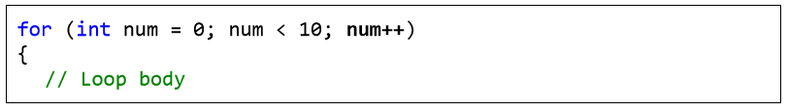
}
This code is executed at each iteration, after the loop’s body has been executed. It is most commonly used to update the value of the countervariable.
The body of the loop contains a block with source code. The loop variables, declared in the initialization block of the loop are available in it.
Here is a complete example of a for-loop:
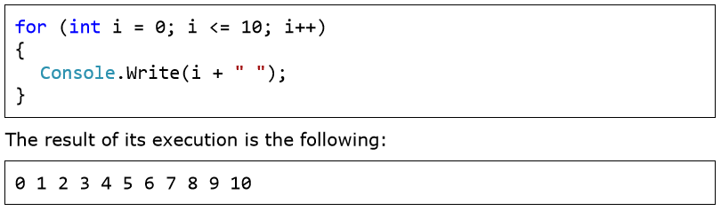
Here is another, more complicated example of a for-loop, in which we have two variables i and sum, that initially have the value of 1, but we update them consecutively at each iteration of the loop:
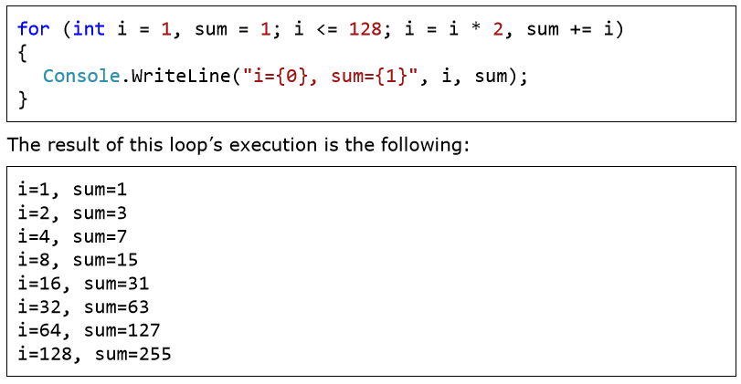

For-Loop with Several Variables
As we have already seen, in the construct of a for-loop we can use multiple variables at the same time. Here is an example in which we have two counters. One of the counters moves up from 1 and the other moves down from 10:
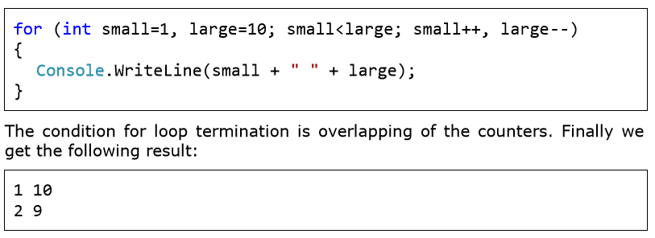
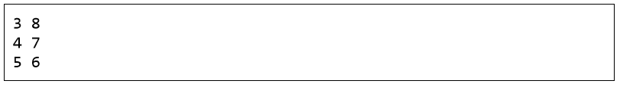

  - Operator "continue"
The continue operator stops the current iteration of the inner loop, without terminating the loop. With the following example we will examine how to use this operator. We will calculate the sum of all odd integers in the range [1…n], which are not divisible by 7 by using the for-loop:

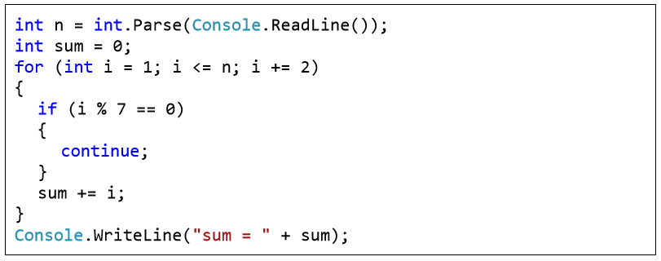
First we initialize the loop’s variable with a value of 1 as this is the first odd integer within the range [1…n]. After each iteration of the loop we check if i has not yet exceeded n (i <= n). In the expression for updating the variable we increase it by 2 in order to pass only through the odd numbers. Inside the loop body we check whether the current number is divisible by 7. If so we call the operator continue, which skips the rest of the loop’s body (it skips adding the current number to the sum). If the number is not divisible by seven, it continues with updating of the sum with the current number.
In this lab we will also examine the nested loops, these are programming constructs consisting of several loops located into each other. The innermost loop is executed more times, and the outermost – less times. Let’s see how two nested loops look like:

for (initialization, verification, update) {
for (initialization, verification, update) {
executable code
}
… }
After initialization of the first for loop, the execution of its body will start, which contains the second (nested) loop. Its variable will be initialized, its condition will be checked and the code within its body will be executed, then the variable will be updated and execution will continue until the condition returns false. After that the second iteration of the first for loop will continue, its variable will be updated and the whole second loop will be performed once again. The inner loop will be fully executed as many times as the body of the outer loop.
Let’s solve the following problem: for a given number n, to print on the console a triangle with n number of lines, looking like this:
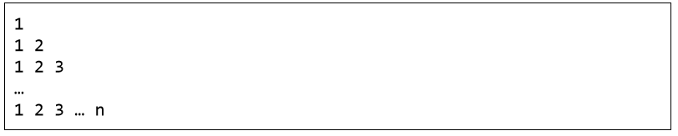
We will solve the problem with two for-loops. The outer loop will traverse the lines, and the inner one – the elements in them. When we are on the first line, we have to print "1" (1 element, 1 iteration of the inner loop). On the second line we have to print "1 2" (2 elements, 2 iterations of the internal loop). We see that there is a correlation between the line on which we are and the number of the elements that we print. This tells us how to organize the inner loop’s structure:
- We initialize the loop variable with 1 (the first number that we will print): col = 1;
- The repetition condition depends on the line on which we are: col <= row;
- We increase the loop variable with one unit at each iteration of the internal loop.

Basically, we need to implement a for-loop (external) from 1 to n (for the lines) and put another for-loop (internal) in it – for the numbers on the current line, which should spin from 1 to the number of the current line. The external loop should go through the lines while the internal – through the columns of the current line. Finally, we get the following code:
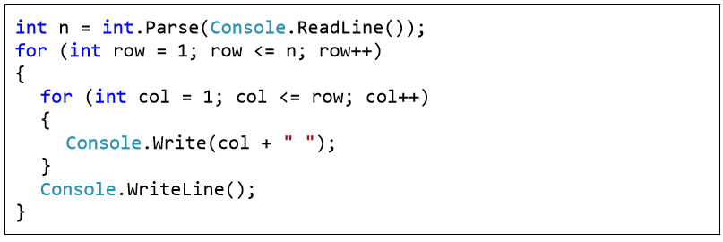
If we execute it, we will make sure that it works correctly. Here is how the result for n=7 looks like:
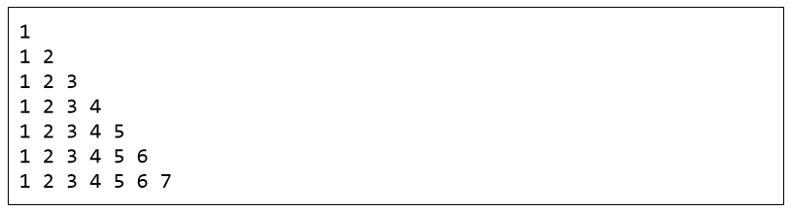

Prime Numbers in an Interval – Example
Let’s consider another example of nested loops. We set a goal to print on the console all prime number in the interval [n…m]. We will limit the interval by a for-loop and in order to check for a prime number we will use a nested while loop:
Console.Write("n = ");
int n = int.Parse(Console.ReadLine());
Console.Write("m = ");
int m = int.Parse(Console.ReadLine());

for (int num = n; num <= m; num++) {
bool prime = true;
int divider = 2;
int maxDivider = (int)Math.Sqrt(num);
while (divider <= maxDivider) {
if (num % divider == 0) {
prime = false;
break;
}
divider++;
}
if (prime) {
Console.Write(" " + num);
} }

Practice Lab Tasks

- Cube series without using power maths function. (Use For loop)
- Square Series without using power maths function (use For loop)
- Repeatedly print the value of the variable xValue, decreasing it by 0.5 each time, as long as xValue remains positive.
- Print the square roots of the first 25 odd positive integers.
- Make a game in C#, in which give 5 tries to the user to guess the value of the number.
- Generate Stars using 2 for loops
*
**
***
****
*****
******

- Write a program that reads from the console a positive integer number N (N < 20) and prints a matrix of numbers as on the figures below:
N = 3 N = 4
