LAB 08: - Arrays

Introduction (Concept Map)
In this chapter we will learn about arrays as a way to work with sequences of elements of the same type. We will explain what arrays are, how we declare, create, instantiate and use them. We will examine one-dimensional arrays.
Arrays are vital for most programming languages. They are collections of variables, which we call elements:
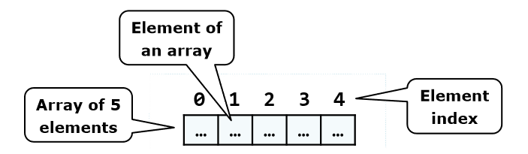
An array’s elements in C# are numbered with 0, 1, 2, … N-1. Those numbers are called indices. The total number of elements in a given array we call length of an array. All elements of a given array are of the same type, no matter whether they are primitive or reference types. This allows us to represent a group of similar elements as an ordered sequence and work on them as a whole. Arrays can be in different dimensions, but the most used are the one dimensional and the two-dimensional arrays. One-dimensional arrays are also called vectors and two-dimensional are also known as matrices.
In C# the arrays have fixed length, which is set at the time of their instantiation and determines the total number of elements. Once the length of an array is set we cannot change it anymore.

Declaring an Array
We declare an array in C# in the following way:

Creation of an Array – the Operator "new"
In C# we create an array with the help of the keyword new, which is used to allocate memory:

Array Initialization and Default Values
Before we can use an element of a given array, it has to be initialized or to have a default value. We can do this in different ways. Here is one of them:
Here is one more example how to declare and initialize an array:
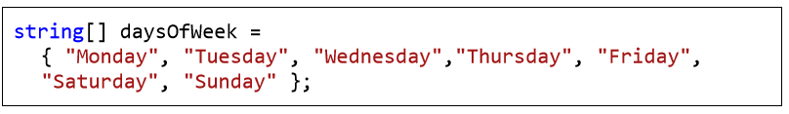

Boundaries of an Array
Arrays are by default zero-based, which means the enumeration of the elements starts from 0. The first element has the index 0, the second – 1, etc. In an array of N elements, the last element has the index N-1.

Access to the Elements of an Array
We access the array elements directly using their indices. Each element can be accessed through the name of the array and the element’s index (consecutive number) placed in the brackets. We can access given elements of the array both for reading and for writing, which means we can treat elements as variables. Here is an example for accessing an element of an array:
Here is an example, where we allocate an array of numbers and then we change some of them:
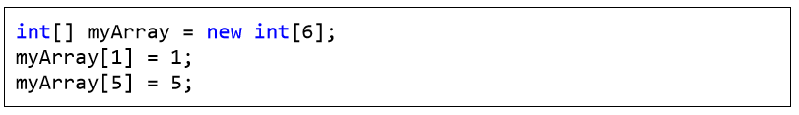
We can iterate through the array using a loop statement. The most common form of such iteration is by using a for-loop:
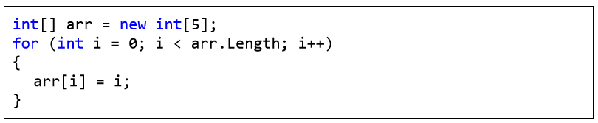

Reading an Array from the Console
Initially we read a line from the console using Console.ReadLine(), and then we parse that line to an integer number using int.Parse() and we set it to the variable n. We then use the number n as length of the array.
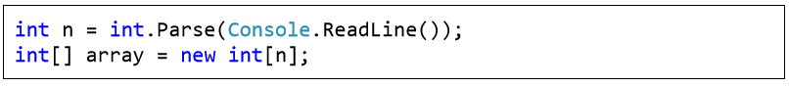
Again we use a loop to iterate through the array. At each iteration we set the current element to what we have read from the console. The loop will continue n times, which means it will iterate through the array and so we will read a value for each element of the array:
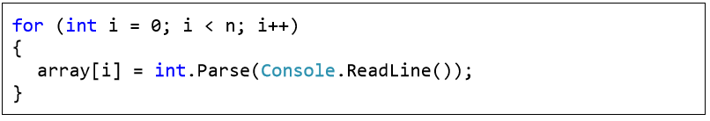

Check for Symmetric Array – Example
An array is symmetric if the first and the last elements are equal and at the same time the second element and the last but one are equal as well and so on. On the figure a few examples for symmetric arrays are shown:
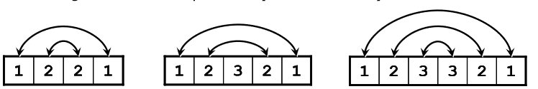

In the next example we will check whether an array is symmetric:
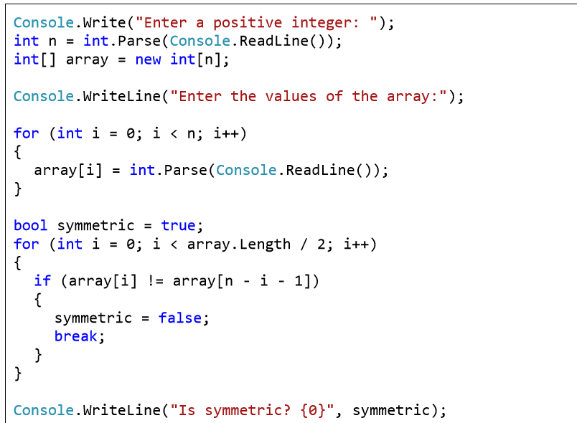

We print the elements of an array by hand, by using a for-loop:
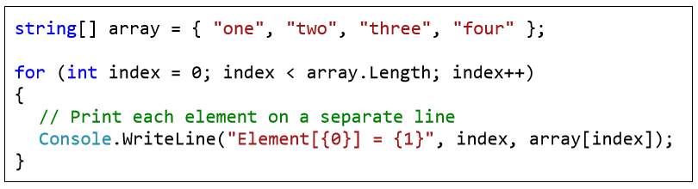

Practice Lab Tasks

- Write a program, which creates an array of 20 elements of type integer and initializes each of the elements with a value equals to the index of the element multiplied by 5. Print the elements to the console.
Array[2]=2*5
- Write a program, which reads two arrays from the console and checks whether they are equal (two arrays are equal when they are of equal length and all of their elements, which have the same index, are equal).
Array[6]={1,1,1,2,2,9}
Array2[6]={1,1,1,2,2,2}
- Make a program in C# in which take 5 numbers from user and then give sum and avg. of them. Using arrays.

