Lab 09– 2D Arrays

LAB 09: - 2D Arrays

Introduction (Concept Map)
In this lab we will learn about multi-dimensional. The one-dimensional arrays are known also as vectors in mathematics. Often we need arrays with more than one dimension. For example, we can easily represent the standard chess board as a two-dimensional array with size 8 by 8 (8 cells in a horizontal direction and 8 cells in a vertical direction). We declare a two-dimensional with int[,].

Those arrays we will call two-dimensional, because they have two dimensions. They are also known as matrices (it is mathematical term). In general arrays with more than one dimension we will call multidimensional. This way we can declare three-dimensional arrays as we add one more dimension:
In theory there is no limit for an array dimensions, but in practice we do not use much arrays with more than two dimensions therefore we will focus on two-dimensional arrays.
Multidimensional Array Declaration and Allocation We declare multidimensional arrays in a way similar to one-dimensional arrays. Each dimension except the first is marked with comma:
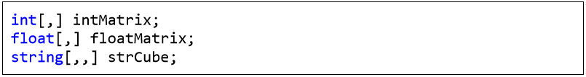
In the example above we create two-dimensional and three-dimensional arrays. Each dimension is represented by a comma in the square brackets []. We are allocating memory for multidimensional arrays by using the keyword new and for each dimension we set a length in the brackets as shown:
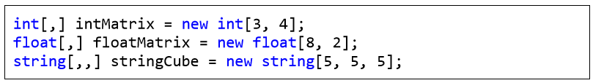
In this example intMatrix is a two-dimensional array with 3 elements of type int[] and each of those 3 elements has a length of 4. Two-dimensional arrays are difficult to understand explained that way. Therefore we can imagine them as two-dimensional matrices, which have rows and columns for the dimensions:
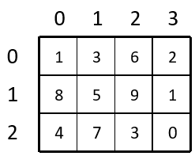
The rows and the columns of the square matrices are numbered with indices from 0 to n-1. If a two-dimensional array has a size of m by n, there are exactly m*n elements.

Two-Dimensional Array Initialization
We initialize two-dimensional arrays in the same way as we initialize one-dimensional arrays. We can list the element values straight after the declaration:
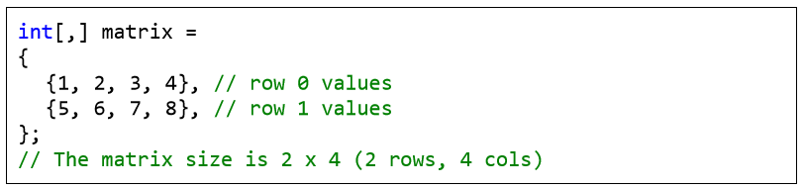
In the example above, we initialize a two-dimensional array of type integer with size of 2 rows and 4 columns. In the outer brackets we place the elements of the first dimension, i.e. the rows of the array. Each row contains one dimensional array, which we know how to initialize.

Accessing the Elements of a Multidimensional Array
Matrices have two dimensions and respectively we access each element by using two indices: one for the rows and one for the columns. Multidimensional arrays have different indices for each dimension.
The above array matrix has 8 elements, stored in 2 rows and 4 columns. Each element can be accessed in the following way:

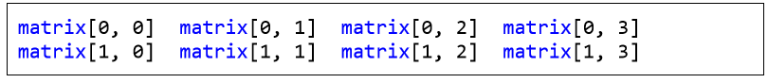
In this example we can access each element using indices. If we assign the index for rows to row, and the index for columns to col, then we can access any element as shown:
Length of Multidimensional Arrays
Each dimension of a multidimensional array has its own length, which can be accessed during the execution of the program.
We can get the number of the rows of this two-dimensional array by using matrix.GetLength(0) and the number of all columns per row with matrix.GetLength(1). So, in this case matrix.GetLength(0) returns 2 and matrix.GetLength(1) returns 4.
Printing Matrices – Example
In the next example we will demonstrate how we can print two-dimensional arrays to the console:
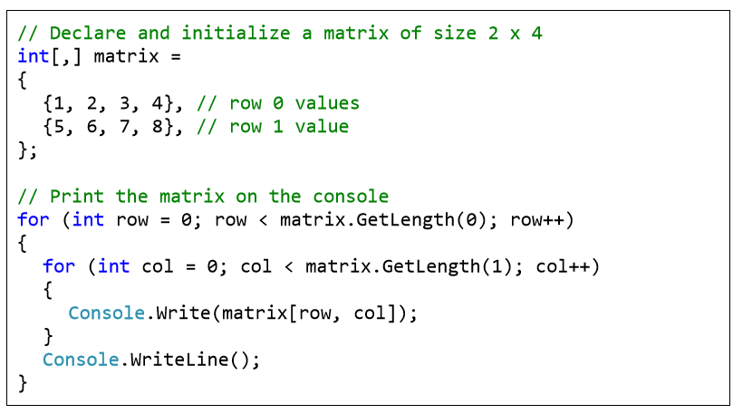
First we declare and initialize an array, which we want to iterate through and print to the console. The array is two-dimensional, therefore we use a for loop which will iterate through the rows and a nested for loop which for each row will iterate through the columns. At each iteration we will print the current element using the appropriate method to access this element by using its two indices (row and column).

Reading Matrices from the Console – Example
In this example we will learn how to read a two-dimensional array from the console. First, we read the values (lengths) of the two-dimensions and then by using two nested loops we assign the value of each element (and in the end we print out the values of the array):
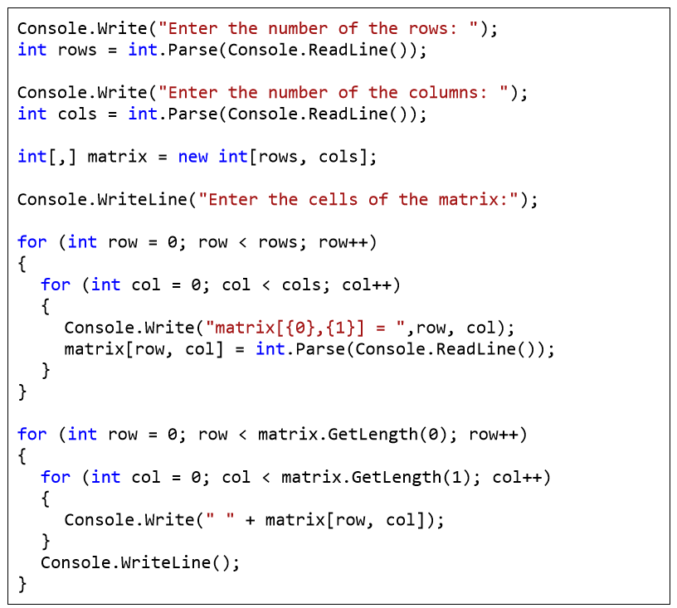
The program output when we execute it (in this case the array consists of three rows and two columns) is:
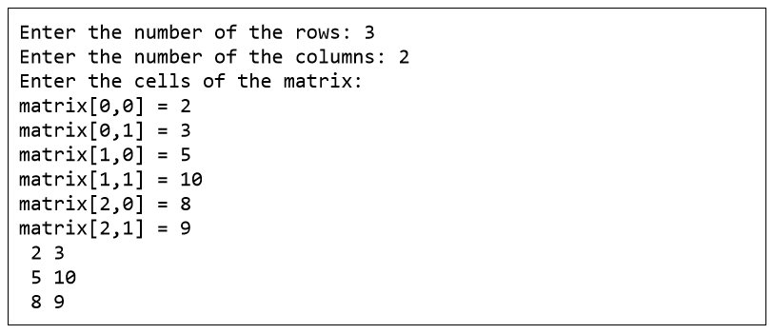

Practice Lab Tasks

- Enter the first matrix and then display it. Secondly, enter the second matrix and then display it. In the result by apply 2D arrays show Addition, subtraction of 2 matrixes.
- Take N number of user data input and make sure N is greater than 10, which contain name of the user, his/her nationality and his/her eye color. You have to show the max color of eye in each country.
- Make a program in C# in which take no. of items, price of items, quantity of items and name of items as input from the user and give the discount according to the following conditions (Use 2D Array):
  - If from rice give discount of 30%.
  - Else if the total amount is greater than 50,000 and less than 100,000 give discount of 20%.
  - Else if the total amount is greater than 100,000 give discount of 30%.

